

Analysis Report
AI Detection Report
2210991248._AmanSharma.docx
Scan details
Scan Time
May 11th, 2026 at 05:56 UTC

Total Pages
10

Total Words
2388

Plagiarism Detection AI Detection



0%

0%

Plagiarism types Text coverage
Identical
Minor Changes
Paraphrased

Excluded
- Omitted Words

Text coverage Words
AI Text 0% 0
Human Text 100% 1
Excluded
Omitted Words 1





C e r t i f i e d b y About this report
help.copyleaks.com


Plagiarism

0%

Results (0)





*Results may not appear because the feature has been disabled. Plagiarism types Text coverage Words
Private Cloud Hub
0
Shared Data Hub Filtered / Excluded
0
0
Internet Sources AI Source Match Current Batch
0 0 0

Identical 0% 0

Minor Changes 0% 0

Paraphrased 0% 0

Excluded
Omitted Words 2
About Plagiarism Detection
Our AI-powered plagiarism scans offer three layers of text similarity detection: Identical, Minor Changes, and Paraphrased. Based on your scan settings we also provide insight on how much of the text you are not scanning for plagiarism (Omitted words).

Identical
One to one exact word matches. Learn more
Minor Changes
Words that hold nearly the same meaning but have a change to their form (e.g. “large” becomes “largely”). Learn more

Paraphrased
Different words that hold the same meaning that replace the original content (e.g. " large" becomes " big") Learn more
Copyleaks Shared Data Hub
Our Shared Data Hub is a collection of millions of user-submitted documents that you can utilize as a scan resource and choose whether or not you would like to submit the file you are scanning into the Shared Data Hub. Learn more

Filtered and Excluded Results
The report will generate a complete list of results. There is always the option to exclude specific results that are not relevant. Note, by unchecking certain results, the similarity percentage may change. Learn more

Current Batch Results
These are the results displayed from the collection, or batch, of files uploaded for a scan at the same time. Learn more

Omitted Words
The portion of text that is not being scanned for plagiarism based on the scan settings. (e.g. the 'Ignore quotations' setting is enabled and the document is 20% quotations making the omitted words percentage 20%) Learn more


AIContent

0%

 |  | Text coverage | Words
AI Text |  | 0% | 0
Human Text |  | 100% | 1
Excluded
Omitted Words 1
About AI Detection
Our AI Detector is the only enterprise-level solution that can verify if the content was written by a human or generated by AI, including source code and text that has been plagiarized or modified. Learn more

AI Text
A body of text that has been generated or altered by AI technology.
Learn more

Human Text
Any text that has been fully written by a human and has not been altered or generated by AI. Learn more

Copyleaks AI Detector Effectiveness
Credible data at scale, coupled with machine learning and widespread adoption, allows us to continually refine and improve our ability to understand complex text patterns, resulting in over 99% accuracy—far higher than any other AI detector—and improving daily. Learn more

Ideal Text Length
The higher the character count, the easier for our technology to determine irregular patterns, which results in a higher confidence rating for AI detection. Learn more

Reasons It Might Be AI When You Think It's Not
The AI Detector can detect a variety of AI-generated text, including tools that use AI technology to paraphrase content, auto-complete sentences, and more. Learn more

User AI Alert History
Historical data of how many times a user has been flagged for potentially having AI text within their content. Learn more

AI Logic
The number of times a phrase was found more frequently in AI vs human text is shown according to low, medium, and high frequency. Learn more

A Review of Artificial Intelligence Integration in Modern
Software Development Practices

Aman Sharma Department of computer science and
engineering
Chitkara University Institute of Engineering and Technology
Rajpura, India
aman1248.be22@chitkara.edu.in
Akshat Khosla Department of computer science and
engineering
Chitkara University Institute of Engineering and Technology
Rajpura, India
akshat1226.be22@chitkara.edu.in
Dr. Shikha Tuteja Department of computer science and
engineering
Chitkara University institute of Engineering and Technology Rajpura, India shikha.1290@chitkara.edu.in

Aditya Aggarwal Department of computer science and
engineering
Chitkara University Institute of Engineering and Technology
Rajpura, India
aditya.1184be22@chitkara.edu.in
Aditya Chauhan Department of computer science and
engineering
Chitkara University Institute of Engineering and Technology Rajpura, India
aditya1190.be22@chitkara.edu.in

development tools developers already use, solutions now pervasive. The AI for software business is booming worth
$674.3 million in 2024, projected to reach ~ $15.7B by 2033. Recent surveys show that more than the 76% of professional developers are already using AI tools, AI is no longer just a cool experiment. This paper explains


Abstract - Artificial intelligence (AI) has revolutionized how
developers write, test, and maintain code. Developers no longer need to code everything from scratch; instead, they employ sophisticated tools that can auto-complete code for them or rapidly identify and fix errors. In this paper, we investigate how AI, particularly data-driven, human language understanding AI apps, is interspersed throughout the software development lifecycle. In particular, we examine the use and usefulness of AI in coding, testing, debugging, and work efficiency. To evaluate AI use throughout software development, we performed a 2024-2026 literature review, studied current industry trends, and tested AI tools in real-world environments. We discovered AI coding assistants are effective at tedious, mind-numbing tasks. AI coding assistants speed development and testing and result in higher-quality code. By 2025, over 80% of professional dev teams were using AI tools, suggesting the rapid and widespread adoption of AI coding assistants. We still have hurdles towards widespread use, such as whether or not we trust AI recommendations, ethical considerations, and the reality that developers need to learn new skills. The rational position is that developers should be using AI as assistants, not replacing them.
Keywords: Artificial Intelligence, Machine Learning, Software Development, Automated Coding, Tech Trends, App Development, Coding Tools
- INTRODUCTION
The software development practice has always improved as the engineers get better tools. From early systems to the modern software development platforms, each new generation of tools has accelerated the development process and led to higher quality software.
Now, the biggest leap in that journey is for artificial intelligence.I A I tools are no longer exclusive to researchers. Millions of developers around the world make AI part of routine day to day development. Smart code auto complete, code from natural English statements, auto bug fixes, these are now in the
how the AI is currently being used for the whole software development life cycle. It discusses how data-driven, language
understanding solutions can be used for coding, automated testing, error prediction, bug fixes. It discusses the challenges facing developers and companies today, do we trust AI models completely, what's the ethical frontier we need to navigate, what skills programmers need to succeed in the AI-enabled workplace.
- LITERATURE REVIEW

There have been a flurry of studies in recent weeks on how AI is shaping software development. These studies try to figure out everything from how new coding tools are tested and adopted by businesses to the technology behind them.

Initially, AI coding tools were very simple. They just predicted what the next line or word of code might be based on a few patterns, and that was not very useful. That all changed with the introduction of large language models. These advanced models were fed massive amounts of code, and so they can understand the context of a project and offer much more useful code.

AI is also transforming testing software. If a machine learning model has details about past errors, it can walk through a new program and look for where bugs might be likely before testing the code. That way, programming teams know where a new program might be prone to issues. This saves time and effort. Multiple studies find it’s getting easier to figure out why a program is crashing. Clever debugging tools can sift through everything – error messages, system logs, developer notes – all at one time to figure out where a program went wrong. That’s especially helpful for beginners, who can correct their own mistakes without having to keep

bothering senior developers. But researchers say the challenges are still significant.
There is concern that people cannot trust AI recommendations because copying AI-code without an
little as 70% to 90% of the time on the build and test cycle for updates and the benefit that it’s using data from older projects to determine where new bugs are more likely to pop up than with older testing methods.

understanding of it can immediately lead to security vulnerabilities. Others are concerned that new programmers
Almost
software teams were
Claude,
Anthropic’s
like
large models
using at least one AI tool by 2025 –
everyone seems
to on it –
of
and
than 80%

will become too reliant on these new tools and never develop basic problem-solving skills. So for now, the consensus opinion is that AI should be used as a tool to speed up
spending
meaning to replace
people but to save time
that
more
be
on
some are spending money
– not
tools
on these
money
– as AI is no longer a fad,

development, not replace humans.
- METHODOLOGY
- Research Approach
but rather part of the job.

Table 1: How AI Affects Different Parts of Development

In this research, we conduct the literature survey on the current adoption of artificial intelligence to your software development. We gather the desired information from the research papers, industry reports and real-world case studies released between 2024 and the early of 2026. We selected these sources because it is up-to-date, well-sourced and focus on the recent AI coding methods.
- Research Scope
Our research focuses on four dimensions, including the AI code generation, AI code testing, AI bug fixing and AI usability improvement for a developer in his day-to-day. For each dimension, we study both the underlying technology and the real-software-developers tools. We include the data from the tech.
- Surveyed Tools and Technologies
In particular, we study the most popular AI coding assistants in use right now, such as GitHub Copilot, Amazon Code-Whisperer and Tabnine. We also review the intelligent testing frameworks and the emerging AI platform that can provide partial automation of some coding tasks. To measure the accuracy of these tools in reality, we collect the data from the public case studies and the reports released by the vendors .
- Evaluation Criteria
To compare these tools and techniques fairly, we look at multiple criteria. The main aspects cover the productivity boost of the developer, the accuracy of the generated codes and the speed of the software development and testing. We also look at the speed of adoption of these tools to a typical team workflow and the spread of these tools in the industry. We also look at the ethical aspects, such as the bias in the AI model and the explainability of the model
- RESULTS AND FINDINGS

Domain
Writing Code Autocomplete
How AI is used
and code suggestions
Testing Selecting the right tests
Fixing Bugs Reading and
understanding error messages

Usuage Enterprise AI development tools

Figure
1: Illustrations of | how AI is used to | generate | code,

test, and team processes.

But starters, what
requires
snippet.
Another
large
issue
developers don't know is why it proposed
needs. Mac
learn
data to
it
AI does
sometimes the
advantages,
even with all the

Impact
31.9% market share

Run 70-90% faster testing times
Largely less time spent hunting down bugs

80% of teams use them by 2025

some
issues remain.
For
not
explain its solutions,
so
that particular

Our findings show that AI has dramatically changed how we
build software from end to end. The biggest influence is that
code learning

a
is the data amount of historical
hine

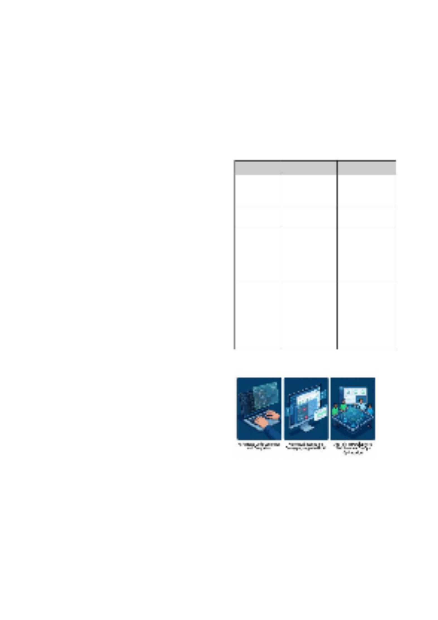
it automatically writes and completes code – a portion that
accounts for almost 31.9% of the total AI spend and generates around $4.0 billion in just 2025. This means that developers are spending money on these tools – not to replace people but to save time in not typing out repetitive lines of code or constantly looking up online basic syntax and commands.
It’s also making testing faster and more effective, as AI can determine which tests are “important” to run instead of having to run them all. The net result is that you can spend as
from, and small or and
these very new AI tools to work with older, legacy computer systems, which can be a tough sell for businesses.
can be challenging
have that. Last,
get
to
new projects often do not
it
importantly,
most
probably
- THE INVINCIBLE FORCES DRIVING AI ADOPTION

There to
are not many big forces that
 |  | are driving | software
start adopting | AI at such a breakneck speed. The big

teams driver
for a
version of their app ideas much faster.
prototype
expert | programmers | to be | able | to | produce

is Beyond writing code, AI will also be heavily involved in the
that developers are pressured to do more with less.

Software is becoming more and more complex to build. And
schedules are
more aggressive. AI tools
becoming more and
take over the boring repetitive errors early and that saves a lot of
time for programmers and
flag
program and
work. They
for the businesses that they serve. Another big driver are how
"DevOps" side of servers,
is between invisible.
servers will bec
running under the hood. As AI improves, the
code and managing
writing
barrier
ome
system
well the
how
on
and doing all the telemetry
things,
updates,
like launching
managing

big
the large
learned in
not just
configurations. And
in
and
coding work
programming languages and
for
useful
really
are
of
a lot
are
So they
code.
huge amounts of
from
they
language models have become. They have
very fluent
daily
All of this is pretty amazing, but there are also a lot of difficult ethical problems that will need to be solved. Researchers should be actively working to ensure that these are fair, that

test environments.
Culture in the workplace is also critical. So we see the teams
user data is private, and that they are fully "explainable" in
terms of how exactly they came to their solution. We also need to figure out who is responsible if the AI writes bad

that have bosses
that enc
that are have things t Things writes,
that culture are fighting to make AI work. There are
don’t
that
that succeed
ones
the
 | hat prevent certain industries from adopting AI |  |  |  |  |  |  |  |  |  |  |  |  | .
about code security, |  |  |  |  |  | who | owns |  | code | t | hat | the |  | AI
and |  | the | fear | of | becoming lazy |  |  | and | dependent |  |  |  | are | all

and learning
with AI. The teams
ourage experimentation
also
code. Remember, this is the only way people will trust AI enough to use it all the time in the future.
VII. REFERENCES
- Grand View Research, "Artificial Intelligence in Software Development Market Size, Share & Trends Analysis Report", Grand View Research, San

big things. And that is especially true for regulated industries like banking, health care, and government.
- CONCLUSION
This
development
in software
a
a nice-to-have
is no longer
that AI
review has shown
Francisco, CA, 2024.
- Menlo
Ventures, " | The State | of Generative | AI in | the Enterprise," Menlo

Ventures Industry Report, 2025. [3]
GitHub, "GitHub Copilot: | Your AI | Pair Programmer," | GitHub I

2024. [Online]. Available: https://github.com/features/copilot
[4]
Amazon Web Services, "Amazon Q Developer (formerly |  |  |  |  |  |  |  | Code-
 |  | Product | Overview," | AWS, | 2024. | [Online]. | Available:

nc.,

experiment.
has become
It
these days. From it's
and
faster
teams move
code, to running tests, to debugging,
produce
writing
AI
true that

is helping
must
Whisperer) https://aws.amazon.com/q/developer/
- T. B. Brown
33,
vol.
Systems (NeurIPS),
et al., "Language models are few-shot learners," in
ocessing
Neural Information

Advances
pp.
2020,

better quality software when used properly. The
not
key must is that AI is there to help developers,
in Pr
1877–1901.
- F.
 | Pedregosa | et al., | "Scikit-learn: Machine | learning in | Python,"

Journal

replace them.
These work. more
tools | are | great for |  |  | doing the |  |  |  | boring, |  | repetitive |  |  |  |  | typing
That | frees |  | devs | up |  | to do |  | the |  | harder, |  | more |  |  | complex,
hard-to-code things |  |  |  |  |  | of | software dev, |  |  |  |  |  | ike | designing

of Machine Learning Research, vol. 12, pp. 2825–2830, 2011.
- M. Kim, S.
Lee, | and | J. | Park, | "Automated | Test Case | Generation | Using

Machine Learning Techniques: A Review," IEEE Transactions on Software
l Engineering, vol. 50, no. 2, pp. 415-430, 2024.

systems and working out logic puzzles. That's where companies get the most bang for the buck.
Anthropic, | "Claude Model | Usage | and | Impact | in | Enterprise

Environments," Anthropic Research, 2025.
- Stack Overflow, "2025 Developer Survey: AI Tools Adoption and Usage," Stack Overflow, 2025.
all | you | need," | in | Advances | in

[10] A. | Vaswani | et | al., | "Attention

Because these tools are such a rapidly moving
edge. But, buying an AI tool is not a magic bullet
to
keep their
want
they
them
ignore
just can't
target,
is Neural

companies
competitive
either. They need to the
especially
to be
and they need
AI-generated
educating
about the
careful
their
code, they need to keep
how
to use
as to
policies
up
setting
be
employees, serious teams
will
that
work
time
have
think
to
take the
that
their
fairness,
security,
into
fewest problems.

t
most
the
if

to
integrate AI
with the
the
It's
ransparency issues.
benefit but
about how
and
Information Processing Systems (NeurIPS), vol. 30, 2017, pp. 5998–6008.

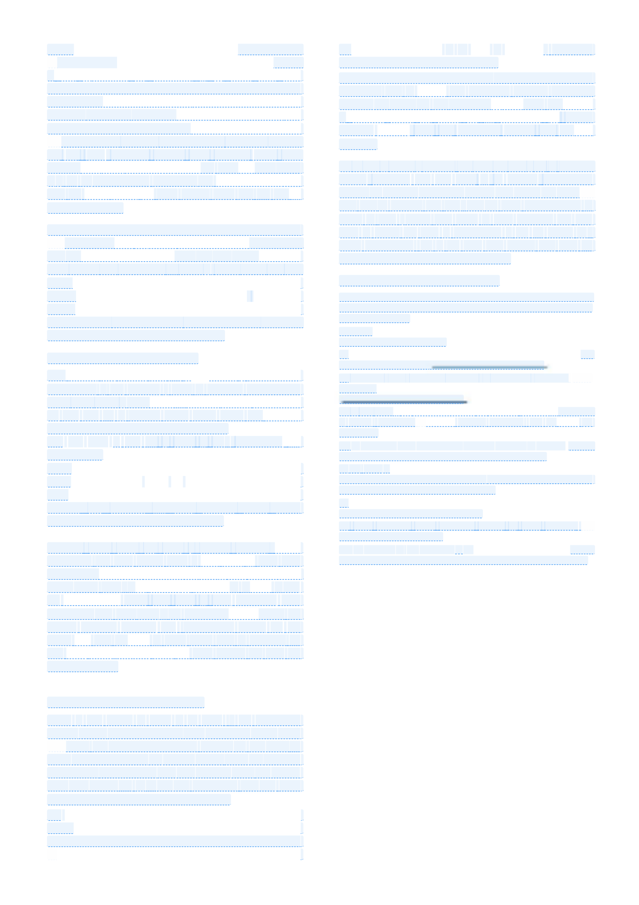
- FUTURE WORK
There is still plenty of work to be done in the combining coding and AI space, especially. The next major trend is the shift from the hinting/autocomplete models we see today to more autonomous smart AI agents that do more of the work themselves. These models will not just give hints on how to write something but be more like teammates that will write code that can be directly used in the project.
We Soon,
will |  | a | lso | shift |  | to |  | more |  | programming |  |  |  | in | plain |  | English.
 | you |  | should |  | be |  | able |  | to | just | type | out | what |  |  | you want |  | an

app to do and the AI will give you the full python code. This is
going | to | be | massive | for beginners | to | learn | from, and | also

